Smart stopcontact

[HLK-PM01 AC-DC supply (5V)](https://nl.aliexpress.com/item/4000105687486.html?spm=a2g0o.productlist.main.3.28a5Pg7qPg7qH5&algo_pvid=64e3280a-2968-45c1-b7b2-363bd3f4f9b7&algo_exp_id=64e3280a-2968-45c1-b7b2-363bd3f4f9b7-0&pdp_ext_f=%7B%22order%22%3A%22150%22%2C%22eval%22%3A%221%22%7D&pdp_npi=4%40dis%21EUR%213.18%212.19%21%21%213.22%212.22%21%402103892f17393589714211553ee734%2110000000273814766%21sea%21BE%210%21ABX&curPageLogUid=tEqtcAiDeM1r&utparam-url=scene%3Asearch%7Cquery_from%3A)

[Esp relaismodule](https://nl.aliexpress.com/item/1005004884839786.html?spm=a2g0o.detail.pcDetailTopMoreOtherSeller.5.3635wbYdwbYdoN&gps-id=pcDetailTopMoreOtherSeller&scm=1007.40196.366991.0&scm_id=1007.40196.366991.0&scm-url=1007.40196.366991.0&pvid=6c14aff4-0d8c-4792-abc9-0a4121fa6ded&_t=gps-id:pcDetailTopMoreOtherSeller,scm-url:1007.40196.366991.0,pvid:6c14aff4-0d8c-4792-abc9-0a4121fa6ded,tpp_buckets:668%232846%238113%231998&pdp_ext_f=%7B%22order%22%3A%22361%22%2C%22eval%22%3A%221%22%2C%22sceneId%22%3A%2230050%22%7D&pdp_npi=4%40dis%21EUR%210.92%210.79%21%21%210.93%210.80%21%402103834817393563448586392ea87b%2112000033141166828%21rec%21BE%21%21ABXZ&utparam-url=scene%3ApcDetailTopMoreOtherSeller%7Cquery_from%3A) (let op kies de optie met ESP-01)

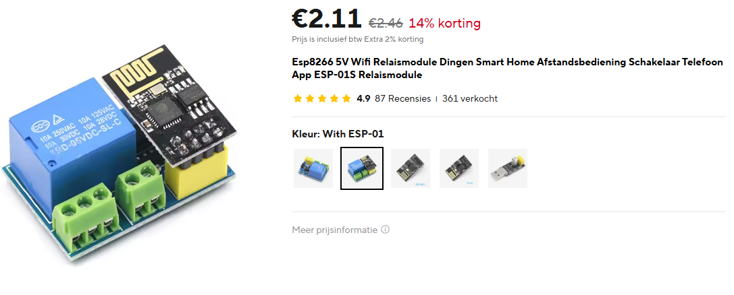

[Esp adapter](https://nl.aliexpress.com/item/1005004242039576.html?spm=a2g0o.productlist.main.9.277f5edajLytex&algo_pvid=7a7c3f38-624c-4925-9a10-bf81aceb09fe&algo_exp_id=7a7c3f38-624c-4925-9a10-bf81aceb09fe-5&pdp_ext_f=%7B%22order%22%3A%222%22%2C%22eval%22%3A%221%22%7D&pdp_npi=4%40dis%21EUR%210.55%210.44%21%21%210.56%210.45%21%40211b80f717393660239476898e18ea%2112000028498031265%21sea%21BE%210%21ABX&curPageLogUid=hpdenYPcpnap&utparam-url=scene%3Asearch%7Cquery_from%3A)   
[Kabel](https://www.elektramat.be/neopreen-kabel-h07rnf-3x1-5-per-meter/?utm_source=google-surfaces&utm_medium=organic&gad_source=1&gclid=CjwKCAiAqrG9BhAVEiwAaPu5zvyadWl6uSOx1pQHPZWt87eFknaaJ5fZoZ8TE5AoV97UsqYT_N0z_xoC-nsQAvD_BwE) (max 1m per persoon)

[Stekker male](https://www.elektramat.be/kopp-stekker-haaks-met-randaarde-en-uitrekoog-zwart-170315005/)

[Stekker female](https://www.elektramat.be/kopp-contrastekker-pa-sh-kunststof-uittrekoog-zij-invoer-zwart/)

Smart deurbel (in bestaande omgeving)  
[HLK-PM01 AC-DC supply (5V)](https://nl.aliexpress.com/item/4000105687486.html?spm=a2g0o.productlist.main.3.28a5Pg7qPg7qH5&algo_pvid=64e3280a-2968-45c1-b7b2-363bd3f4f9b7&algo_exp_id=64e3280a-2968-45c1-b7b2-363bd3f4f9b7-0&pdp_ext_f=%7B%22order%22%3A%22150%22%2C%22eval%22%3A%221%22%7D&pdp_npi=4%40dis%21EUR%213.18%212.19%21%21%213.22%212.22%21%402103892f17393589714211553ee734%2110000000273814766%21sea%21BE%210%21ABX&curPageLogUid=tEqtcAiDeM1r&utparam-url=scene%3Asearch%7Cquery_from%3A)

[Relais](https://nl.aliexpress.com/item/1005007268682246.html?spm=a2g0o.productlist.main.1.18f8oKPuoKPu8e&algo_pvid=17b28d06-99f0-4386-a44b-97ce6d17d6db&algo_exp_id=17b28d06-99f0-4386-a44b-97ce6d17d6db-0&pdp_ext_f=%7B%22order%22%3A%222%22%2C%22eval%22%3A%221%22%7D&pdp_npi=4%40dis%21EUR%211.26%210.70%21%21%211.27%210.70%21%40211b61bb17393526534315602e2c30%2112000040008575478%21sea%21BE%210%21ABX&curPageLogUid=nUdJEdUzU70M&utparam-url=scene%3Asearch%7Cquery_from%3A)

[Esp32](https://nl.aliexpress.com/item/1005002783258820.html?spm=a2g0o.productlist.main.13.2ab72854HusE9B&algo_pvid=1782c1e3-46d3-4e8a-8934-36fadc45ab8b&algo_exp_id=1782c1e3-46d3-4e8a-8934-36fadc45ab8b-7&pdp_ext_f=%7B%22order%22%3A%222%22%2C%22eval%22%3A%221%22%7D&pdp_npi=4%40dis%21EUR%213.07%212.30%21%21%213.11%212.33%21%402103847817393537505876886ecfa8%2112000044556752224%21sea%21BE%210%21ABX&curPageLogUid=316IrnA2qCXO&utparam-url=scene%3Asearch%7Cquery_from%3A) (let op kies de optie ESP32 CP2102 TYPE-C USB 30pin)  
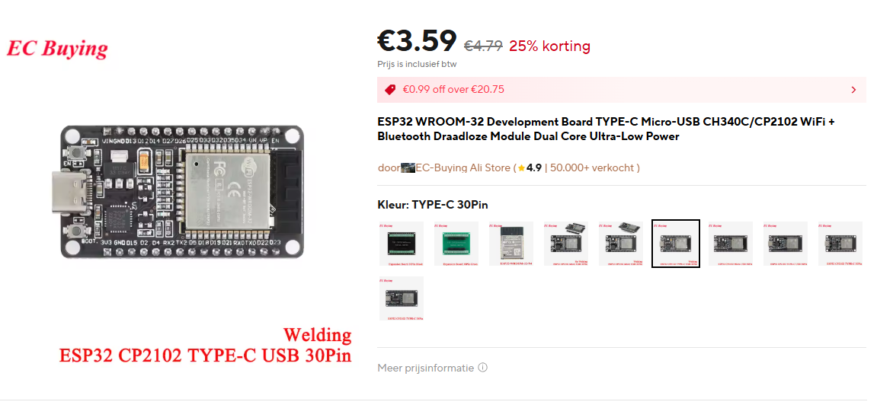

Smart garagepoort  
[HLK-PM01 AC-DC supply (5V)](https://nl.aliexpress.com/item/4000105687486.html?spm=a2g0o.productlist.main.3.28a5Pg7qPg7qH5&algo_pvid=64e3280a-2968-45c1-b7b2-363bd3f4f9b7&algo_exp_id=64e3280a-2968-45c1-b7b2-363bd3f4f9b7-0&pdp_ext_f=%7B%22order%22%3A%22150%22%2C%22eval%22%3A%221%22%7D&pdp_npi=4%40dis%21EUR%213.18%212.19%21%21%213.22%212.22%21%402103892f17393589714211553ee734%2110000000273814766%21sea%21BE%210%21ABX&curPageLogUid=tEqtcAiDeM1r&utparam-url=scene%3Asearch%7Cquery_from%3A)

[Relais](https://nl.aliexpress.com/item/1005007268682246.html?spm=a2g0o.productlist.main.1.18f8oKPuoKPu8e&algo_pvid=17b28d06-99f0-4386-a44b-97ce6d17d6db&algo_exp_id=17b28d06-99f0-4386-a44b-97ce6d17d6db-0&pdp_ext_f=%7B%22order%22%3A%222%22%2C%22eval%22%3A%221%22%7D&pdp_npi=4%40dis%21EUR%211.26%210.70%21%21%211.27%210.70%21%40211b61bb17393526534315602e2c30%2112000040008575478%21sea%21BE%210%21ABX&curPageLogUid=nUdJEdUzU70M&utparam-url=scene%3Asearch%7Cquery_from%3A)

[Magnatic contact sensoren](https://nl.aliexpress.com/item/33048168546.html?spm=a2g0o.cart.0.0.30ba38da2N0Vfn&mp=1&gatewayAdapt=glo2nld) (let op kies de optie NO & NC)  
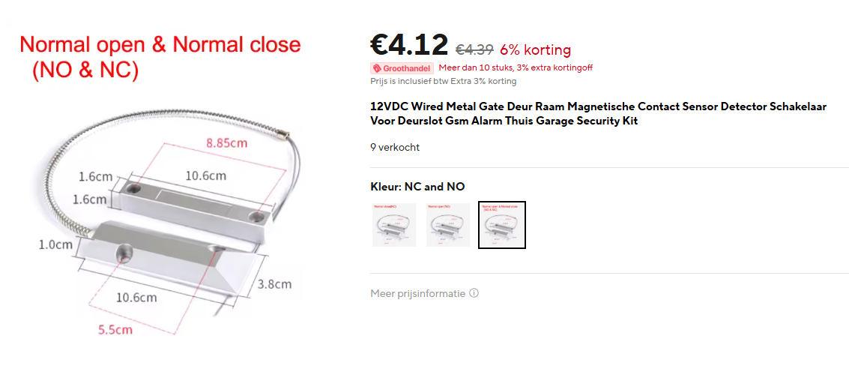

[Esp32](https://nl.aliexpress.com/item/1005002783258820.html?spm=a2g0o.productlist.main.13.2ab72854HusE9B&algo_pvid=1782c1e3-46d3-4e8a-8934-36fadc45ab8b&algo_exp_id=1782c1e3-46d3-4e8a-8934-36fadc45ab8b-7&pdp_ext_f=%7B%22order%22%3A%222%22%2C%22eval%22%3A%221%22%7D&pdp_npi=4%40dis%21EUR%213.07%212.30%21%21%213.11%212.33%21%402103847817393537505876886ecfa8%2112000044556752224%21sea%21BE%210%21ABX&curPageLogUid=316IrnA2qCXO&utparam-url=scene%3Asearch%7Cquery_from%3A) (let op kies de optie ESP32 CP2102 TYPE-C USB 30pin)  


General

Soldeerbout

Tin

Electronica draad

Enkele USB to USB-C kabels  
3x [IoT houses](https://www.amazon.nl/KEYESTUDIO-Elektronica-Elektrotechniek-Educatieve-Volwassenen/dp/B0B7637837/ref=sr_1_14?dib=eyJ2IjoiMSJ9.0yCLjaN09aplVAnxKmNyrMvS16cV82fpvOFt8NPXNIReDOrbdBWuilGXPimjGlaEsK6LvXbZeYDGzptkdUiRQ2A_Ng3sy3xoYXgZhOk3Qep33KJQzFshsDhPNDqs0Y2COmbDJii3qRQHT_3c-xYSUbB8-PlfY4fR_8Bl0TSDOa2BAAKrJFg-JYNuatXpAUhsVeD9kbaGOKeTFGbXAT3MQOyE0WkCeF8lYtHmgqClVm6-XOMQTcBV1MZygaO1sEKeAlZEvlfSPcWqI8Ga6R5mmlCqyrXPRJ16D-smKjSdEOn-vSYEoCOIHAS24NQHDkIYQOZn4nr7J43FgBtlV9zIebcXn8MvfCWQsTg_InJh7VIok0Q3v6DkNG2hXF1dJNyol3PiOvMQ0v8O8ZxXHt9Ip-HC5EcG-LNjX05zjKADv9YHxaWbC8pDd05Cy-mYzmFK.oqHImET1JmLOTZmF2izZYs0fgT19ZPZkp_qGEMnwihs&dib_tag=se&keywords=esp32+kit&qid=1738162590&sr=8-14)